**HTML Laboratory Activities:**

1. Creating HTML Documents

* HTML File Structure
* How to Write a Tag
* Majority of tags in HTML come in pairs:
  + the opening and closing tags.
  + these tags form a container around the page content they define
  + these tags indicate to your Web browser the **beginning** and **end** of a particular element.
* Not all HTML tags have closing tags (<br/>, <hr/>
* To indicate where a given element begins, place the appropriate tag before it.
  + Appropriate tag for paragraph is **p** sandwiched by the less-than (**<**) and greater-than **(>)** symbols

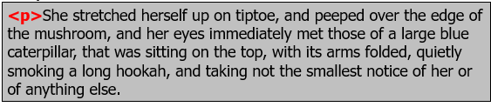

* Placement of the closing tag is the same as the opening tag, except for the addition of the forward slash

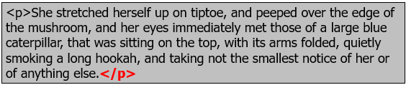

* When defining a tag’s *attributes*, which are its individual properties, enter them inside the opening tag and separate them by spaces.



* To set the attribute equal to an appropriate value, define that value by using an equal sign and quotation marks

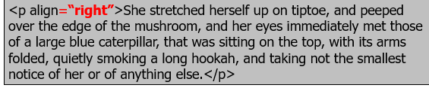

* Naming Files and Extensions
  + HTML filename should be in the suffix “.html” or “.htm”

1. Working with HTML Tags
   * Basic Structure Tags
   * An HTML document’s basic structure is really just a series of large containers, inside of which you define the two main sections of your page:
     + - * the document head - <head></head>
         * the document body - <body></body>

* Steps in Creating HTML Document Template
  1. Open your text editor and begin a new blank document
  2. In line 1, type the tag **<!DOCTYPE html>** at the top of the document. This specify the HTML version of the document. In this case, its HTML5
  3. In the next line, type the tag **<html>**. This tag begins the document’s primary container.
  4. This opening <html> tag requires a closing tag, so hit Enter (or Return) twice to move down a few lines and then enter the closing tag, **</html>**.

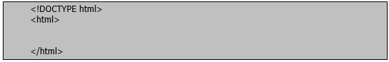

* 1. Place your cursor on the line between the opening and closing tags. Type the tag **<head>**, which defines the head section of the document.
  2. Hit Enter (Return) twice and then type **</head>**

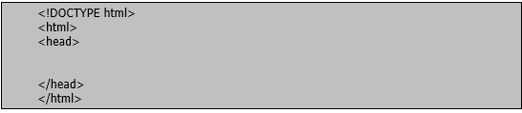

* 1. To create the document title, which appears in the title bar of the browser window, enter <title> and </title> between the head tags of your document.

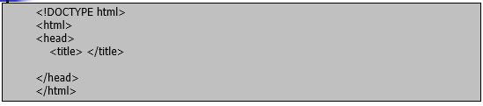

* 1. The last element to add to your document template is the body section. Between the closing </head> and the closing </html> tags, enter opening and closing body tags <body> & </body>

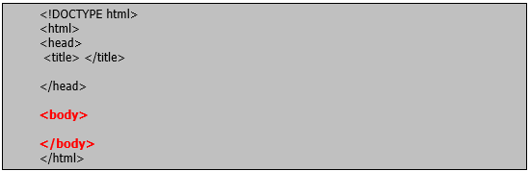

* 1. Save your document. Name it like “blank.html”. You may use this template each time you want to start a new document by opening it, making changes, and resaving the file with a different name.
  + Working with Paragraph
    - * HTML only recognizes single spaces between characters. Other than a single tap on the Spacebar, HTML has little regard for how you physically type your paragraphs.
      * What HTML does recognize is tags to format paragraphs.
      * The align attribute is the <p> tag’s only attribute.
      * To indicate the beginning of a paragraph, enter an opening <p> tag in the <body> section of the HTML Document.

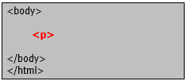

* + - * To mark the end of a paragraph, place the closing </p> tag at the end of your paragraph.

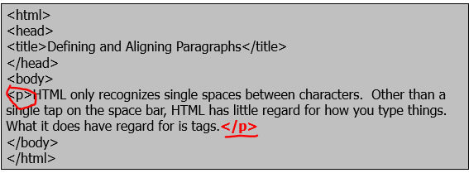

* + - * To align a paragraph, add the align attribute to the paragraph tag.



* + - * Set the align attribute equal to left, right, center, or justified.



* + Line Breaks <br>
  + Equivalent to one carriage return, it is used to start text on a new line Multiple <br> tags in a row will create a large vertical space on a web page.

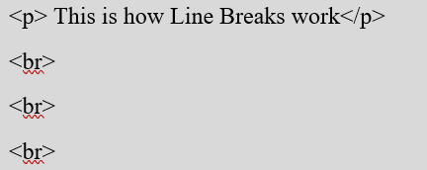

1. Lists, Headings, and Dividers
   * Lists

* Ordered List

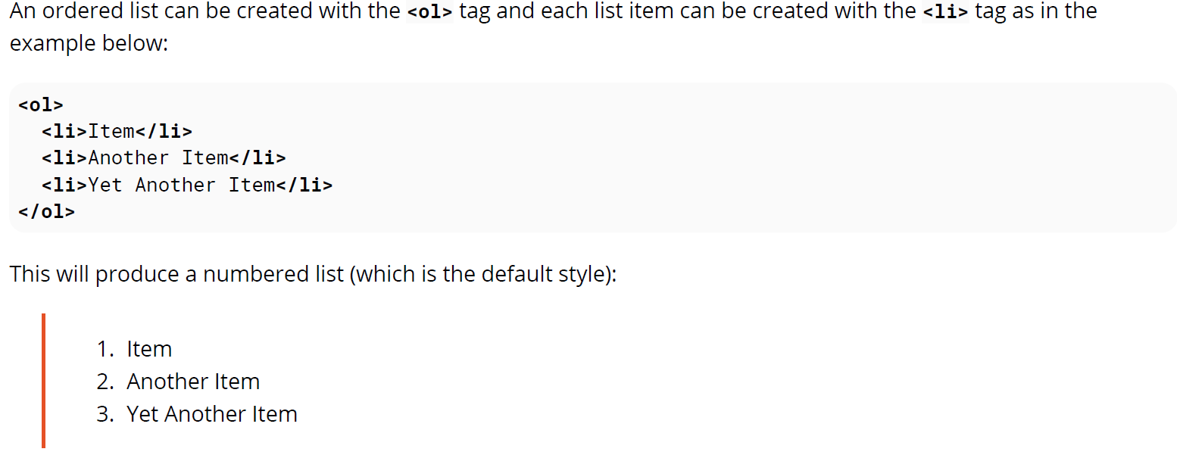

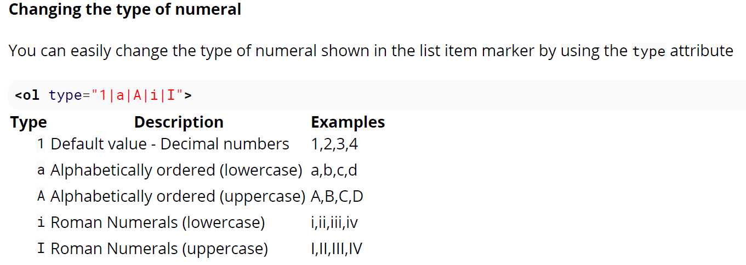

* Unordered List
  + Type of Unordered List
    - Disc (default type)
    - Circle
    - Square
    - None



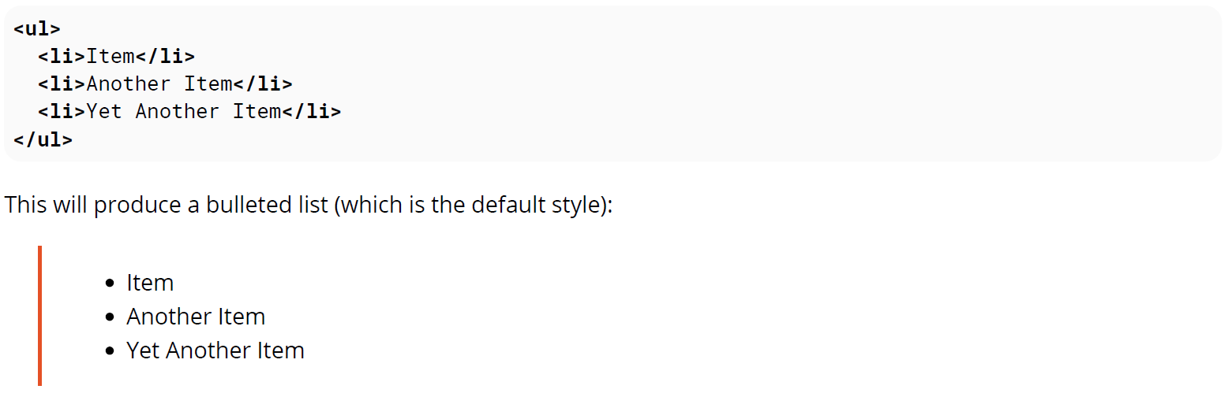

* Description List
  + A description list (or *definition list*, as it was called before HTML5) can be created with the dl element. It consists of name-value groups, where the name is given in the dt element, and the value is given in the dd element.

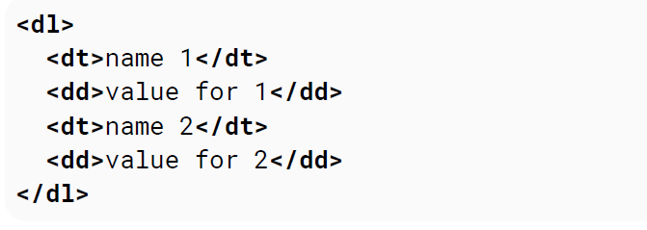

* A name-value group can have more than one name and/or more than one value (which represent alternatives).

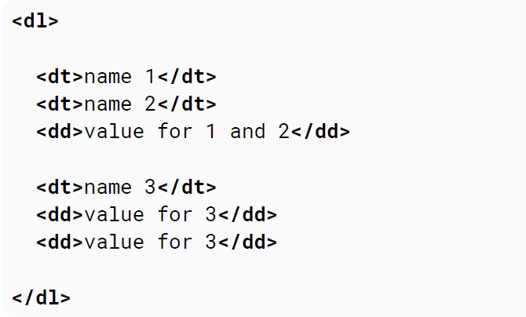

* + Headings
* There are six levels of headings, ranging from a heading 1 (the largest) to a heading 6 (the smallest).
* To format a word or phrase as a heading, place an opening heading tag in front of it.

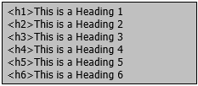

* Place a corresponding closing heading tag after the word or phrase, as shown below.

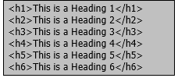

* Sample HTML Code for Headings:

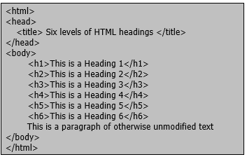

* + Dividers
    - * **Div Element** <div> </div>

The div element in HTML is a container element that encapsulates other elements and can be used to group and separate parts of a webpage. A div by itself does not inherently represent anything but is a powerful tool in web design.

The **<div>** element usually has no specific semantic meaning by itself, simply representing a division, and is typically used for grouping and encapsulating other elements within an HTML document and separating those from other groups of content. As such, each **<div>** is best described by its contents.

<div>

<p>This is a paragraph using Div. tag</p>

</div>

The div element is typically a block-level element, meaning that it separates a block of an HTML document and occupying the maximum width of the page.

Div elements can be useful for stylistic purposes or to wrap multiple paragraphs within a section that are all to be annotated in a similar way.

1. Formatting Text (Font Face, Font Size, Font Color)

* **Font Face** <font face=” ”> </font>

To show text in a particular font, use the font name such as “Helvetica” or “Times New Roman” or “Arial”. Be aware that using some fancy font from your computer means that the person viewing that page must also have that font installed on their computer too, otherwise it will look totally different to them. Font is selected sequentially according to priority

<p> <font face=”Arial, Helvetica, sans-serif”>By itself, this tag has no effect on the text you apply it to. You actually specify your chosen fonts as a value of the face attribute. The most important thing to understand about specifying fonts in HTML is that you don’t really determine the font the visitor sees – their computer does. </font></p>

Font is selected sequentially according to priority.

* **Font Size**

To specify the font size, use the size attribute of the <font> tag.

The size attribute accepts a numeric value from one of two scales

* Absolute scale – ranges from 1 (the smallest) to 7 (the largest). A size value of 3 is the same as the browser’s current default font size of 12pt. (also called the *base* font size).
  + Other scales are 1 = 7.5pt., 2 = 10pt., 4 = 13.5pt., 5 = 18pt., 6 = 24pt., and 7 = 36pt.

<p> <font size=”2”>All text affected by this font tag is now set to size 2.</font> </p>

* Relative scale - runs from –7 to +7 and sets the font size in relation to the base font of the browser. So setting the font size to +1 makes the text appear one size larger than the base font size.
  + The relative scale is best used in conjunction with the <basefont> tag, with which you can force a font size for an entire document.

<basefont size=”2”>

<p>All text in this document will default to size 2.

<font size=”+3”>T</font>he first letter in this sentence has now been punched up to a size 5 using a +3 size value. </p>

* **Font Color**
* Although the HTML standard only recognizes 16 predefined color words (Black, Green, Silver, Lime, Gray, Olive, White, Yellow, Maroon, Navy, Red, Blue, Purple, Teal, Fuchsia, Aqua)
* In the <font> tag, the face attribute sets the typeface and the size attribute sets the text size.
* In HTML, colors can be defined using hexadecimal notation (a six-character code for expressing the combined red, green, and blue values of affected pixels) or a number of predefined English equivalents.
* There are different methods for defining font color, with or without using the <font> tag’s color attribute.
* Steps in setting the Font Color:
  1. To define the font color for a preexisting <font> tag, simply insert the color attribute and set it equal to your chosen color value.

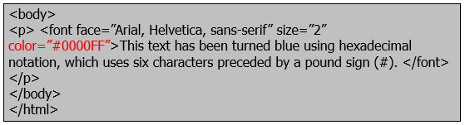

* 1. You can also control the font color by simply adding a <font> tag with only a color attribute defined.

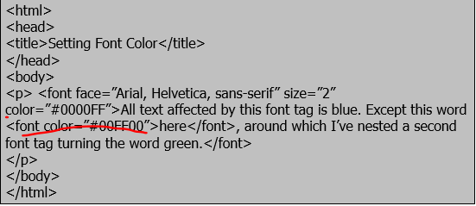

* 1. To use predefined color names instead of hexadecimal values, set the color attribute to equal the word color of your choice

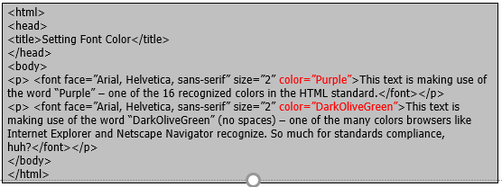

* 1. To define the default text color for your entire document, instead of relying on the <font> tag, use the text attribute of the <body> tag.

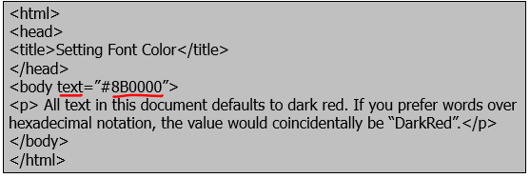

**Recommended Readings/Viewings:**

<https://www.w3schools.com/html/default.asp>

https://websitesetup.org/html-tutorial-beginners/

https://www.tutorialspoint.com/online_html_editor.php

**EVALUATION**

**References:**

HTML5NotesforProfessional.PDF

Histories-of-the-net-and-the-web.pdf

Internet-the-complete-reference.pdf

ISOC-History-of-the-Internet_1997.pdf